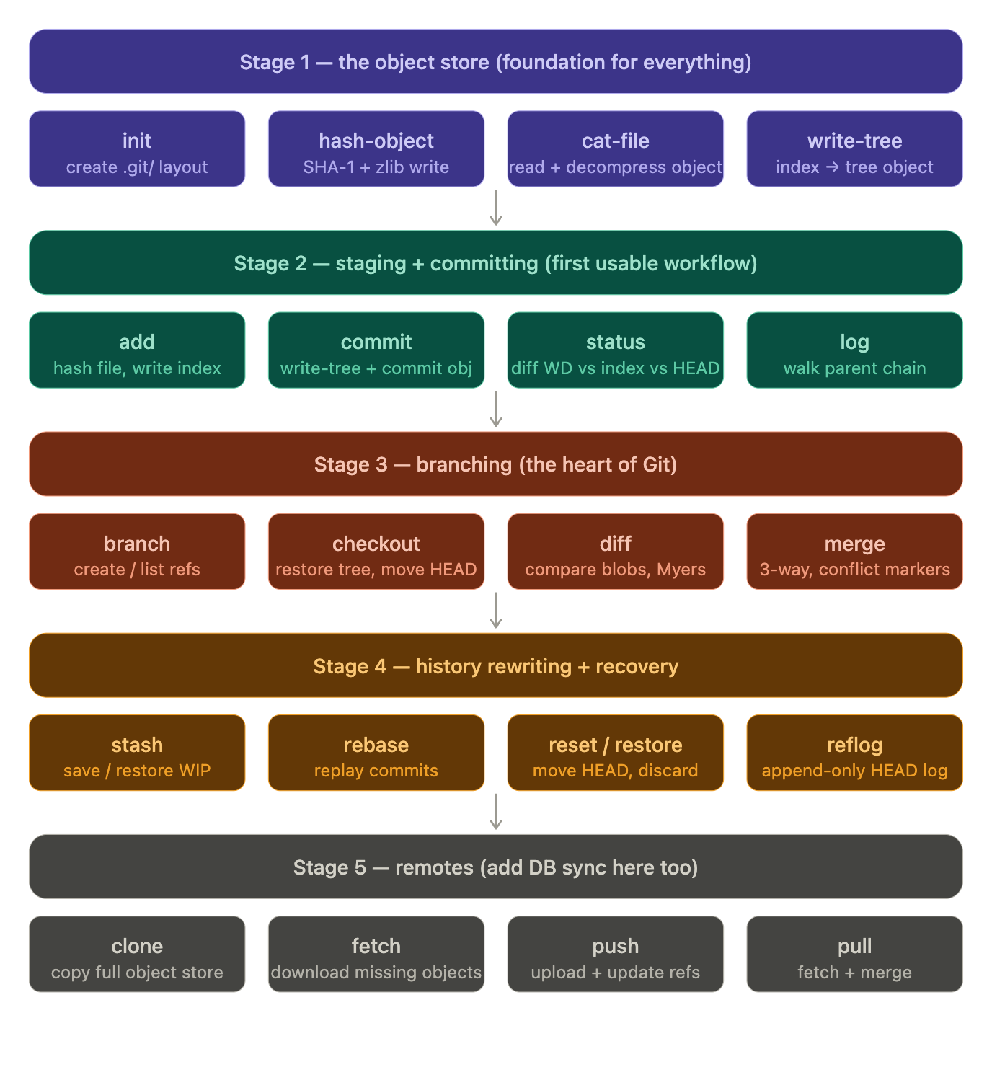

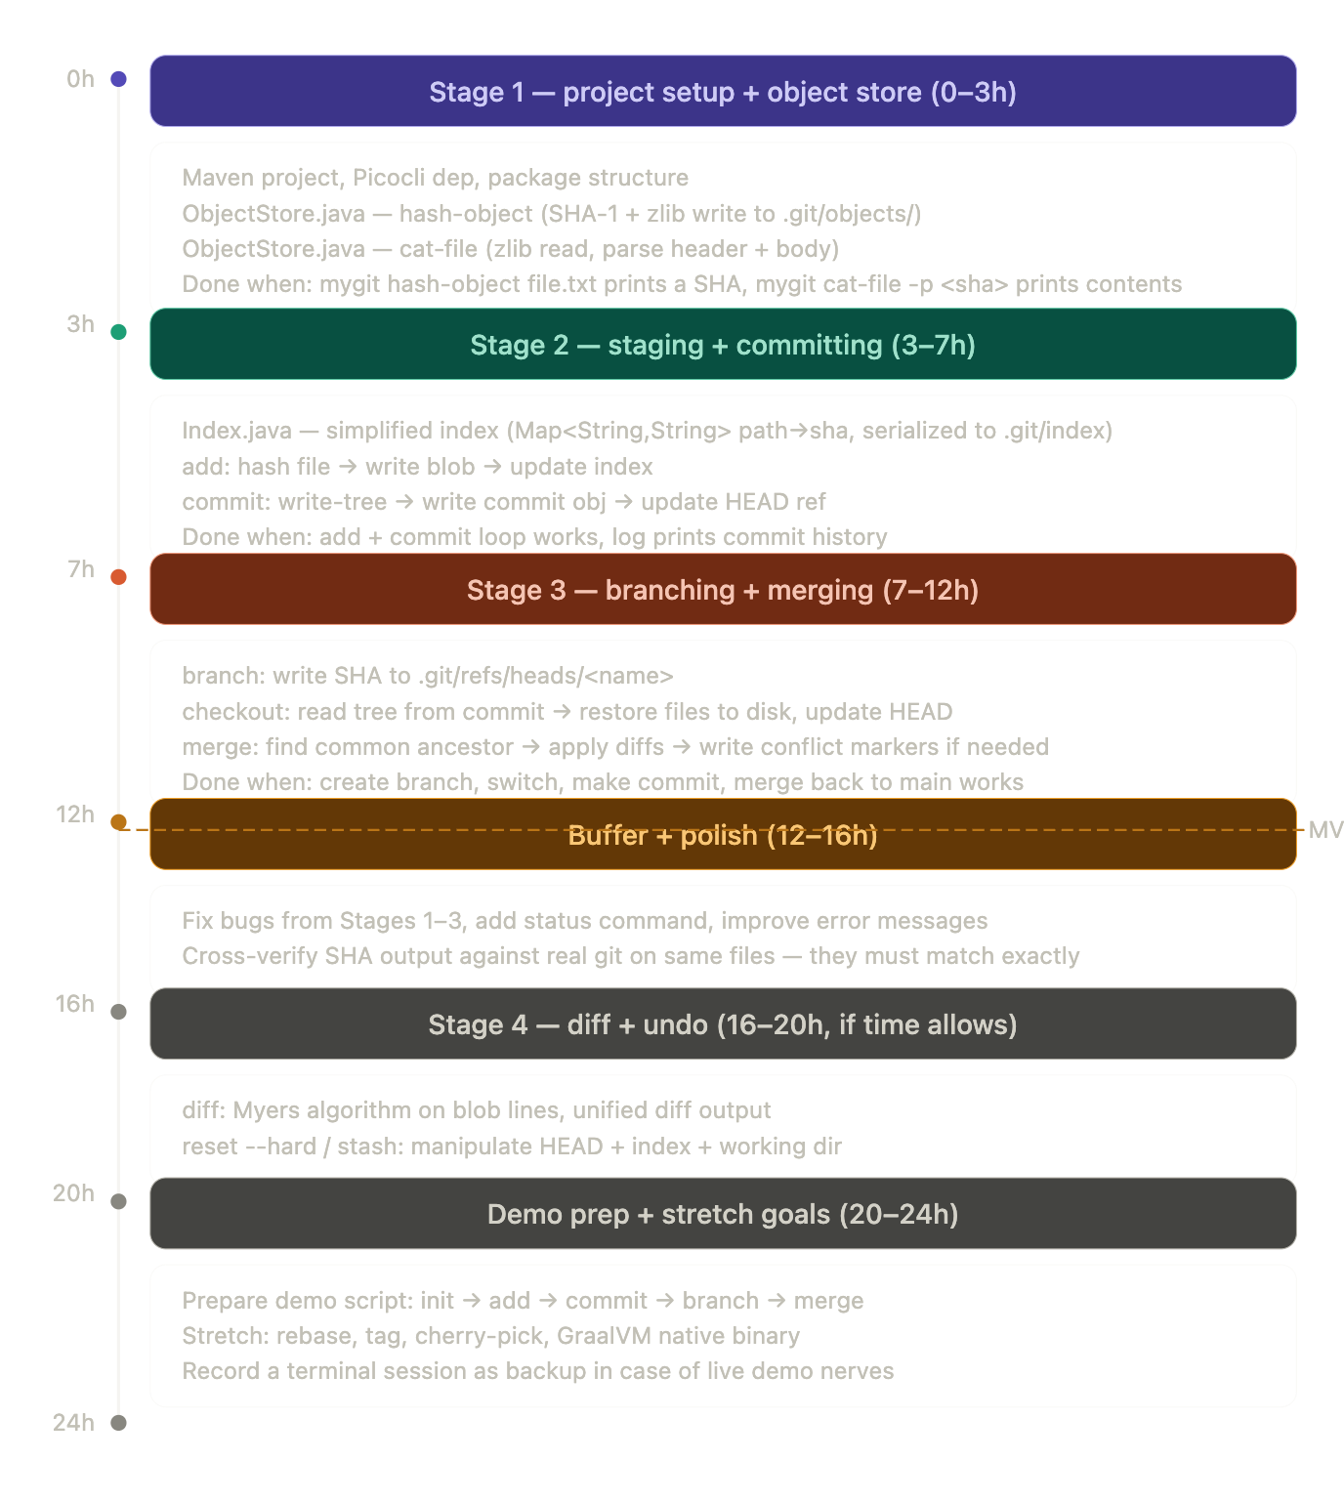

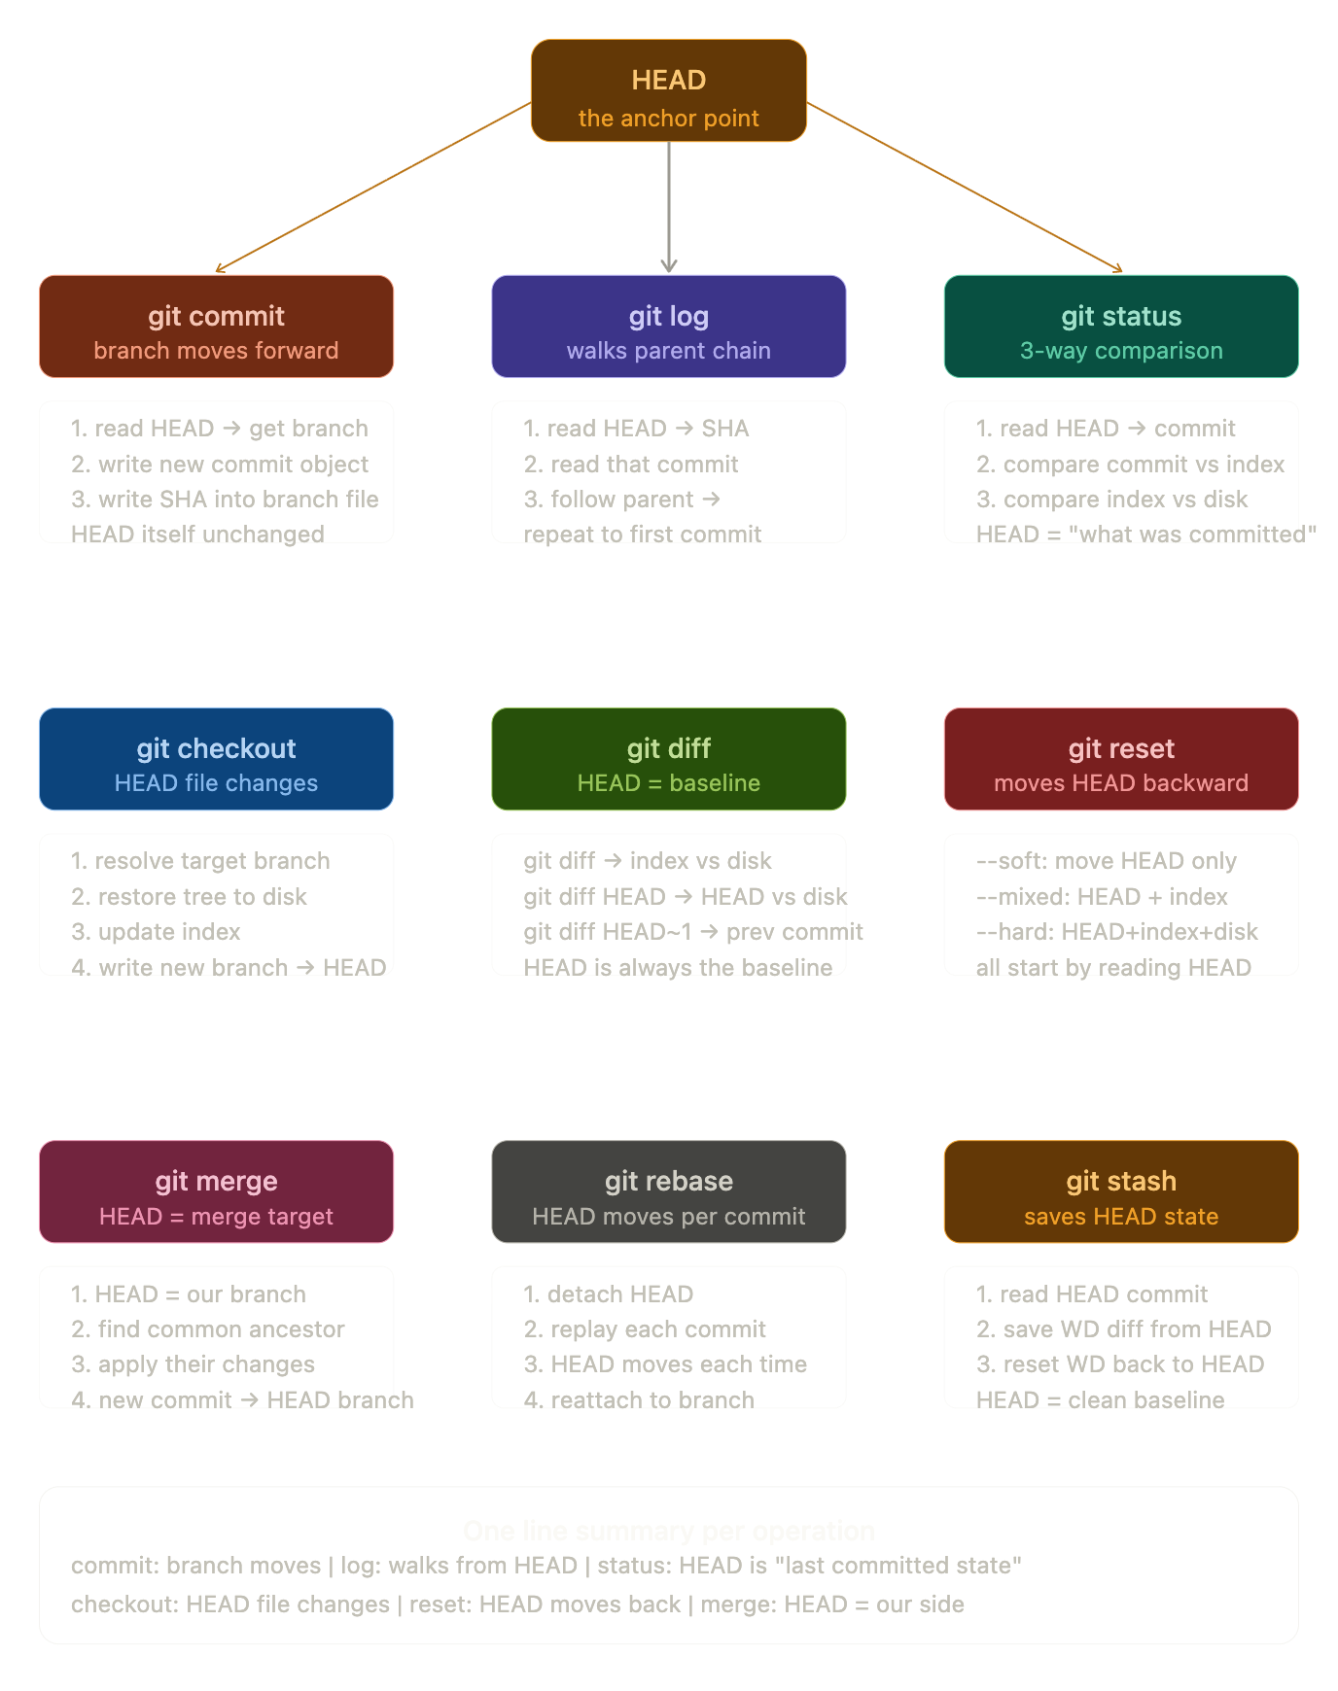

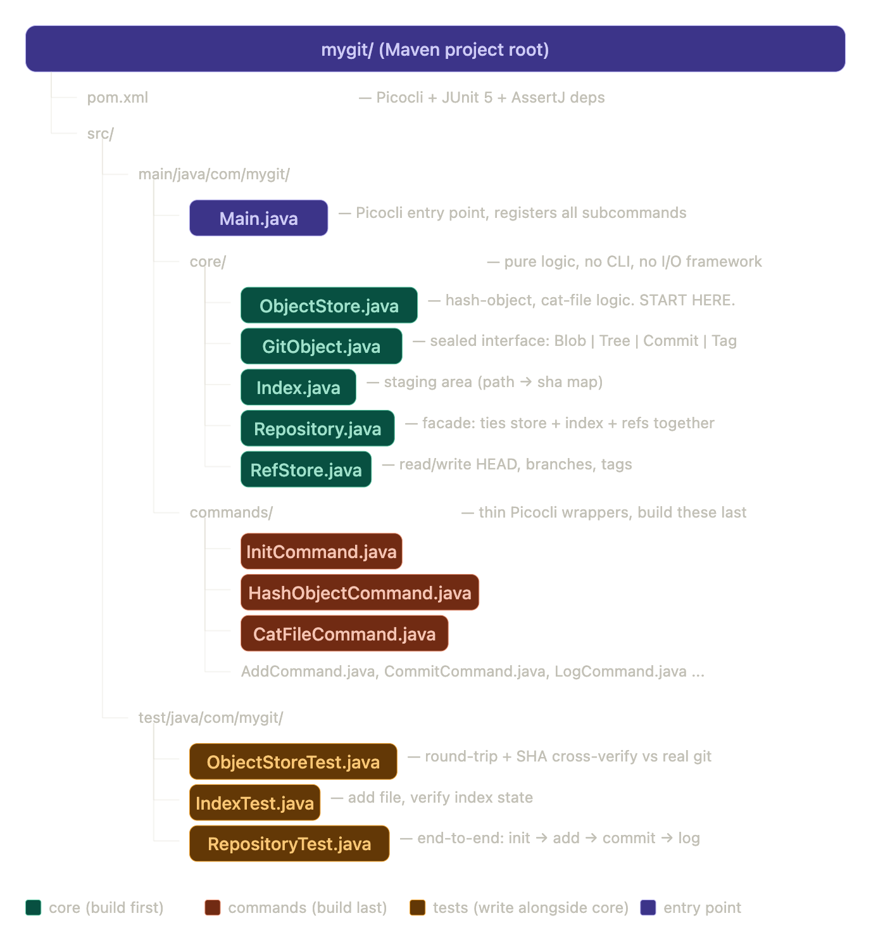

Git add
- Creates a empty .git repository, does nothing else
- 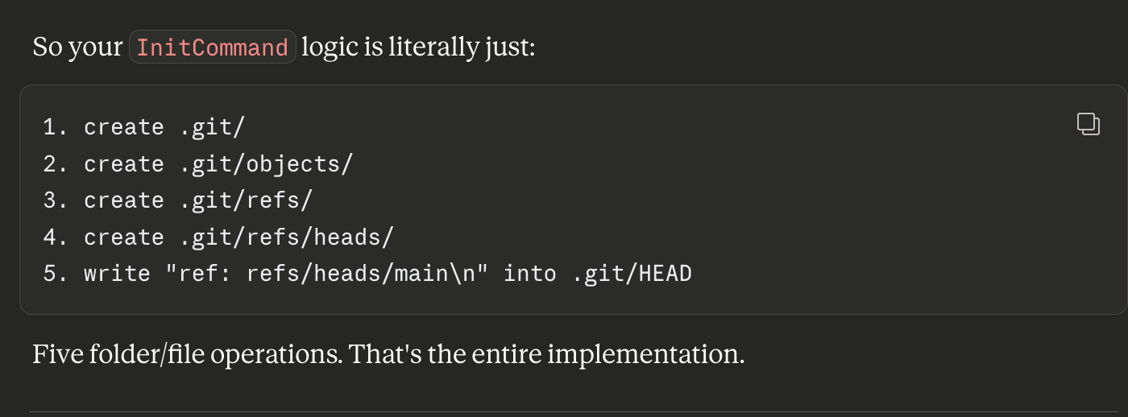
- The three things inside .git/ that matter right now:
- HEAD — a text file containing ref: refs/heads/main. This is Git saying "you are currently on the main branch." That's all it is — one line of text.
- objects/ — empty folder. This is where every version of every file will be stored. Right now nothing is tracked so it's empty.
- refs/heads/ — empty folder. This is where branch pointers live. Empty because you haven't made any commits yet.
- The key insight: at this point, Git knows your project exists but knows absolutely nothing about Hello.java. The file is "untracked." Git is just watching from the sidelines.
- Nothing gets hashed, nothing gets stored, no snapshot is taken. git init is purely about creating the .git/ directory structure.

Here's the exact order with the logic for each file:

File 1 — GitObject.java
What it is: Just data shapes. No logic, no methods. Simply defines what the four object types look like in Java.
Why first: Every other file references these types. ObjectStore returns them, Repository manipulates them. Nothing can be written without knowing what a GitObject looks like.
Logic to implement:
- A sealed interface called GitObject with one method — type() that returns the string type name
- Four record classes implementing it — Blob, Tree, Commit, Tag
- Each record holds only the data that object type carries:
Blob → needs: byte[] content
Tree → needs: List<TreeEntry> entries
Commit → needs: String treeSha, String parentSha, String author, String message
Tag → needs: String objectSha, String name, String message
A TreeEntry is a helper record inside Tree — one entry in a directory listing:
TreeEntry → needs: String mode, String name, String sha

File 2 — ObjectStore.java
What it is: The only class that reads and writes .git/objects/. Everything that goes into or comes out of the object store passes through here.
Why second: This is the core engine. Index, RefStore, Repository all depend on this working correctly first.
Logic to implement — 3 methods:
Method 1 — hashObject(byte[] content, String type, boolean write)
1. build header string → "blob 13\0" (type + space + length + null byte)
2. convert header to bytes
3. concatenate header bytes + content bytes into one array
4. run SHA-1 on the combined array
5. convert 20 raw bytes → 40 hex char string
6. if write == true:
zlib compress the combined array
derive path: .git/objects/{sha[0:2]}/{sha[2:]}
create parent directory if not exists
write compressed bytes to that path
7. return sha string
Method 2 — readObject(String sha)
1. derive path from sha: .git/objects/{sha[0:2]}/{sha[2:]}
2. read all bytes from that file
3. zlib decompress the bytes
4. find the \0 null byte position in decompressed bytes
5. everything before \0 → header (e.g. "blob 13")
6. everything after \0 → raw content bytes
7. parse header to get type string
8. return a GitObject — switch on type:
"blob" → new Blob(content)
"tree" → parseTree(content)
"commit" → parseCommit(content)
"tag" → parseTag(content)
Method 3 — writeTree() ← used by commit later
1. read the index (get all path → sha entries)
2. for each entry build a tree entry line:
"100644 filename\0" + 20 raw SHA bytes
3. concatenate all entries
4. call hashObject with type "tree"
5. return tree sha

File 3 — ObjectStoreTest.java
What it is: Tests that verify your ObjectStore works correctly before you build anything on top of it.
Why third: You must verify hashing is correct before moving on. If your SHA doesn't match real Git's SHA on the same input, every single thing built on top will be wrong.
Logic to implement — 4 tests:
Test 1 — blob round trip
1. create a temp directory
2. write "hello\n" to a file in it
3. call hashObject on those bytes with type "blob" and write=true
4. call readObject with the returned sha
5. assert returned content equals "hello\n"
Test 2 — SHA matches real Git
1. hash "hello\n" with your implementation
2. the expected SHA for "hello\n" as a blob is:
"8227640f7f965bfe41e81cd04816e55b7f8c0da0" (known value, not random)
3. assert your sha equals this expected value exactly
Test 3 — object file exists on disk
1. call hashObject with write=true
2. derive the expected path → .git/objects/{sha[0:2]}/{sha[2:]}
3. assert that file exists on disk
Test 4 — different content = different SHA
1. hash "hello\n" → sha1
2. hash "hello\n!" → sha2
3. assert sha1 does not equal sha2

File 4 — RefStore.java
What it is: The only class that reads and writes .git/HEAD and .git/refs/. Manages branch pointers.
Why fourth: Repository needs this to know the current branch when committing and logging.
Logic to implement — 4 methods:
Method 1 — readHead()
1. read .git/HEAD as a string
2. trim whitespace
3. return raw string → either "ref: refs/heads/main" or a sha
Method 2 — resolveHead()
1. call readHead()
2. if it starts with "ref: ":
strip "ref: " prefix → get "refs/heads/main"
read .git/refs/heads/main
return that sha (trimmed)
else:
return it directly (already a sha — detached HEAD)
Method 3 — updateHead(String commitSha)
1. call readHead()
2. if starts with "ref: ":
get the ref path → "refs/heads/main"
write commitSha into .git/{refpath}
else:
write commitSha directly into .git/HEAD
Method 4 — createBranch(String name, String sha)
1. build path → .git/refs/heads/{name}
2. create parent dirs if needed
3. write sha into that file

File 5 — Index.java
What it is: The staging area. A map of filepath → sha that persists to .git/index.
Why fifth: Repository.add() and Repository.commit() both need this. add writes to it, commit reads from it to build the tree.
Logic to implement — 4 methods:
Method 1 — load()
1. if .git/index does not exist → return empty map
2. read .git/index line by line
3. each line format: "{sha} {filepath}"
4. split each line on whitespace
5. put sha → filepath into a LinkedHashMap
6. return the map
Method 2 — save(Map<String, String> entries)
1. build a string — one line per entry:
"{sha} {filepath}\n"
2. write string to .git/index
Method 3 — add(String filepath, String sha)
1. load current index into map
2. put filepath → sha into map (overwrites if already exists)
3. save map back to disk
Method 4 — getEntries()
1. just call load() and return the map

File 6 — Repository.java
What it is: The facade that ties everything together. Commands talk only to this class — never to ObjectStore, Index, or RefStore directly.
Why sixth: Depends on all four previous classes being complete and tested.
Logic to implement — 5 methods:
Method 1 — init(Path directory)
1. create directory/.git/
2. create directory/.git/objects/
3. create directory/.git/refs/
4. create directory/.git/refs/heads/
5. write "ref: refs/heads/main\n" into directory/.git/HEAD
6. print "Initialized empty repository in {path}"
Method 2 — add(Path filePath)
1. read file bytes from filePath
2. call objectStore.hashObject(bytes, "blob", true) → get sha
3. call index.add(relativePath, sha)
4. print nothing (same as real git)
Method 3 — commit(String message, String author)
1. call objectStore.writeTree() → get treeSha
2. call refStore.resolveHead() → get parentSha (null if first commit)
3. build commit content string:
"tree {treeSha}\n"
+ (parentSha != null ? "parent {parentSha}\n" : "")
+ "author {author} {timestamp}\n"
+ "committer {author} {timestamp}\n"
+ "\n"
+ "{message}\n"
4. call objectStore.hashObject(commitContent, "commit", true) → commitSha
5. call refStore.updateHead(commitSha)
6. print "[main {commitSha[0:7]}] {message}"
Method 4 — log()
1. call refStore.resolveHead() → get current commitSha
2. loop:
read commit object by sha
print sha, author, message
get parent sha from commit
if no parent → break
sha = parentSha
repeat
Method 5 — status()
1. get index entries → staged files
2. for each file in working directory:
hash it (without writing)
compare hash to index entry
if different or not in index → "modified" or "untracked"
3. compare index entries to last commit tree
if in index but not in commit → "staged for commit"
4. print results

File 7 — Main.java + commands
What it is: The Picocli wiring. Each command is a thin wrapper — parse the args, call Repository, done.
Why last: By this point all the logic is done and tested. Commands are just the UI layer — 10–15 lines each.
Logic for each command — all follow same pattern:
InitCommand → new Repository().init(Path.of("."))
HashObjectCommand → new ObjectStore(gitDir).hashObject(fileBytes, "blob", write)
CatFileCommand → new ObjectStore(gitDir).readObject(sha) → print content
AddCommand → new Repository(Path.of(".")).add(Path.of(filename))
CommitCommand → new Repository(Path.of(".")).commit(message, author)
LogCommand → new Repository(Path.of(".")).log()
StatusCommand → new Repository(Path.of(".")).status()

That's the complete build order. Start with GitObject.java — it's the simplest file, no logic, just data shapes, and everything else depends on it. Want me to give you the code for it now?

Perfect approach. Here's what ObjectStore.java needs to have — just the structure and what each method should do, no code:

Fields
one field:
Path gitDir → the path to .git/ folder
→ set in the constructor

Constructor
ObjectStore(Path repoRoot)
→ takes the project root (where .git/ lives)
→ sets gitDir = repoRoot.resolve(".git")

Method 1 — hashObject
signature:
String hashObject(byte[] content, String type, boolean write)

what it does:
1. build header string → type + " " + content.length + "\0"
2. convert header to bytes
3. join header bytes + content bytes into one array called `full`
4. SHA-1 hash `full` → get 20 raw bytes
5. convert 20 bytes → 40 hex char string (the sha)
6. if write is true:
compress `full` with zlib
split sha into folder (first 2 chars) + filename (remaining 38)
build path → gitDir/objects/{folder}/{filename}
create parent directories
write compressed bytes to that path
7. return sha string

Method 2 — readObject
signature:
GitObject readObject(String sha)

what it does:
1. split sha into folder + filename
2. build path → gitDir/objects/{folder}/{filename}
3. read all bytes from that file
4. zlib decompress the bytes
5. find position of \0 null byte in decompressed array
6. header = everything before \0 → parse to get type
7. content = everything after \0
8. switch on type:
"blob" → return new GitObject.Blob(content)
"tree" → return parseTree(content)
"commit" → return parseCommit(content)
"tag" → return parseTag(content)

Method 3 — parseCommit (private helper)
signature:
private GitObject.Commit parseCommit(byte[] content)

what it does:
1. convert content bytes to string
2. split into lines
3. read line by line:
line starts with "tree " → extract treeSha
line starts with "parent " → extract parentSha
line starts with "author " → extract author
empty line → everything after = message
4. return new GitObject.Commit(treeSha, parentSha, author, committer, message)

Method 4 — parseTree (private helper)
signature:
private GitObject.Tree parseTree(byte[] content)

what it does:
tree content is binary, not text. format per entry:
"{mode} {name}\0{20 raw sha bytes}"

1. create empty list of TreeEntry
2. loop through bytes:
read bytes until space → mode string
read bytes until \0 → name string
read next 20 bytes → raw sha bytes
convert 20 bytes → hex sha string
add new TreeEntry(mode, name, sha) to list
3. return new GitObject.Tree(list)

Method 5 — writeTree (used by commit)
signature:
String writeTree(Map<String, String> indexEntries)

what it does:
1. create a ByteArrayOutputStream
2. for each entry in indexEntries (filepath → sha):
write "100644 {filename}\0" as bytes
convert sha hex string → 20 raw bytes
write those 20 bytes
3. call hashObject(treeBytes, "tree", true)
4. return the tree sha

Private helper — toHex
signature:
private String toHex(byte[] bytes)

what it does:
converts raw byte array to hex string
each byte → 2 hex chars using String.format("%02x", b)

Private helper — hexToBytes
signature:
private byte[] hexToBytes(String hex)

what it does:
opposite of toHex
converts 40 char hex string → 20 raw bytes
needed when writing tree entries (sha stored as raw bytes not hex)
loop in steps of 2:
take 2 chars → parse as hex integer → cast to byte

Imports you will need
import java.io.*;
import java.nio.file.*;
import java.security.MessageDigest;
import java.security.NoSuchAlgorithmException;
import java.util.*;
import java.util.zip.*;

That's everything ObjectStore.java needs. Give it a try on your own — write each method one at a time. Don't worry about getting it perfect first try. When you're done or get stuck, share your code and we'll review it together.

Sure. Here's the core logic of every command you've built, in plain English — no code, just what each one does internally.

init
creates 5 things on disk:
.git/ folder
.git/objects/ folder — blobs, trees, commits go here
.git/refs/ folder
.git/refs/heads/ folder — branch pointers go here
.git/HEAD file — "ref: refs/heads/main"

that's it. nothing else happens.
your actual files are untouched.

add
for each file:
1. read file bytes from disk
2. build header → "blob {size}\0"
3. SHA1(header + content) → 40 char hex string
4. zlib compress (header + content)
5. write compressed bytes to .git/objects/{sha[0:2]}/{sha[2:]}
6. write "{sha} {filepath}" into .git/index

two things created:
blob object in .git/objects/ (permanent, never deleted)
index entry (staging area, updated on each add)

commit
1. read index → get all staged filepath → sha pairs
2. build tree object:
for each index entry:
write "100644 {filename}\0{20 raw sha bytes}"
SHA1 + zlib + write to .git/objects/
→ tree sha

3. build commit object (plain text):
"tree {treeSha}\n"
"parent {parentSha}\n" ← skipped for first commit
"author {name} {timestamp}\n"
"committer {name} {timestamp}\n"
"\n"
"{message}\n"
SHA1 + zlib + write to .git/objects/
→ commit sha

4. update branch pointer:
read HEAD → "ref: refs/heads/main"
write commitSha into .git/refs/heads/main

three new objects created:
tree object
commit object
branch file updated

log
1. read HEAD → get branch name
2. read branch file → get latest commit SHA
3. loop:
read commit object by SHA
print SHA, author, message
get parentSha from commit
if parentSha is null → stop
SHA = parentSha
repeat

just walks the parent chain backwards.
nothing written to disk.

status
three-way comparison:

comparison 1 — index vs last commit:
read last commit → read its tree → get committed files
for each file in index:
not in last commit → "new file" (staged, never committed)
sha differs → "modified" (staged change)
prints as "Changes to be committed"

comparison 2 — disk vs index:
walk every file on disk
for each file:
hash it (don't store)
not in index → "untracked" (never added)
sha differs index → "modified" (changed since last add)
prints as "Changes not staged" or "Untracked files"

nothing written to disk.
purely reads and compares.

hash-object
low level plumbing command.
takes a file, computes its SHA.
optionally stores it as a blob.

used internally by add.
useful for debugging — verify your SHA matches real git.

cat-file
low level plumbing command.
takes a SHA, reads the object, prints its contents.

-t → prints the type ("blob", "tree", "commit", "tag")
-p → pretty prints the content

used for debugging — inspect any object in .git/objects/.

How they all connect
init → creates the empty .git/ structure
add → blob created + index updated
commit → tree created + commit created + branch moves
log → reads commit chain backwards from HEAD
status → compares disk vs index vs last commit
disk files → add → index → commit → object store
↑
permanent history
nothing ever deleted

The one core idea behind all of it
Everything in Git is built on three primitives:
SHA = identity (same content = same SHA, always)
blob = content (what a file contains)
pointer = reference (HEAD → branch → commit → tree → blobs)
Every command is just reading or writing these three things in different combinations. add creates blobs. commit creates trees and commits. log follows pointers. status compares SHAs.
Ready to move to Stage 3 — starting with branch?

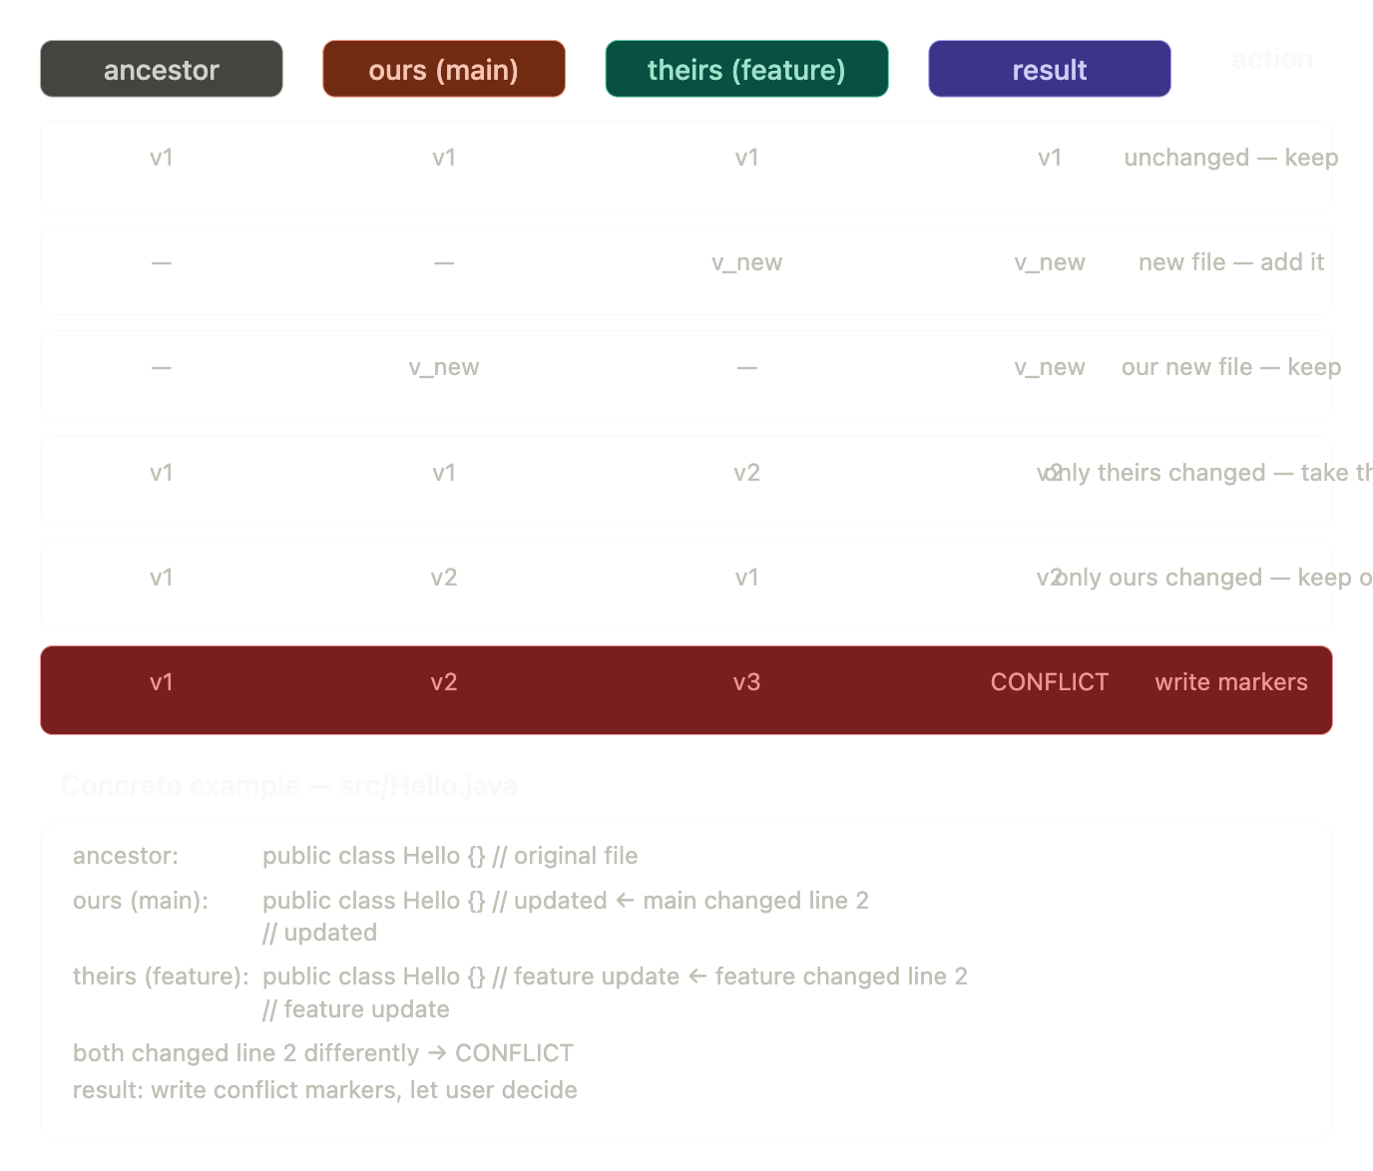

1. branch (30 min) — just file operations
2. checkout (1 hour) — restore tree to disk
3. diff (1 hour) — LCS algorithm
4. merge (1.5 hour) — fast-forward first
5. reset (45 min) — move HEAD + optional index/files
6. stash (45 min) — special commit
Git log –graph (can be added)
Config logic can be written
Implement gitignore logic

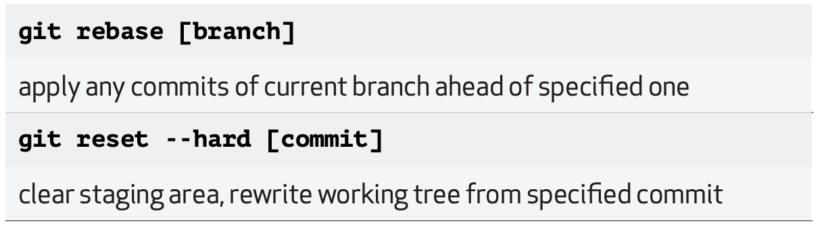

Restore
Reset
Stash
Git log -graph
Config logic
Gitignore
Rebase
And a terminal based ai agent with TUI that converts natural language to git commands and execute it (I think this is unique and stand out feature which anyone else is not building) and every one else is trying to build ui first
Should I add remote (push pull clone) first or the agent first (or are both possible in 5 hrs)
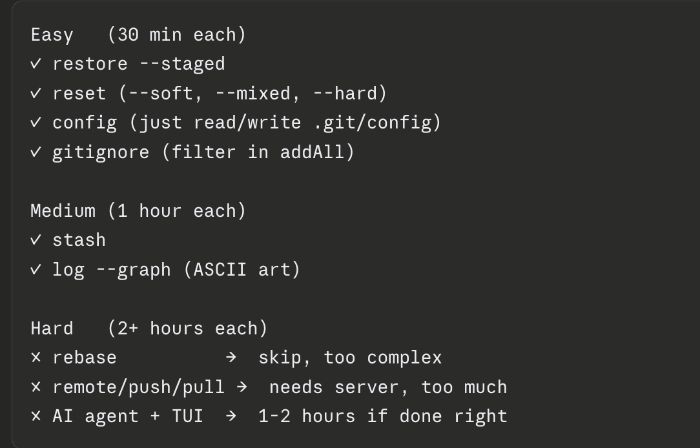

Here's the complete command reference:

Core commands
mygit init [directory]
creates .git/ structure in current or specified directory

mygit add <file> [files...]
stages one or more files for next commit

mygit add .
stages all files in current directory recursively

mygit commit -m "message"
creates a commit from staged files

mygit commit -m "message" -a "Name <email>"
creates a commit with explicit author

mygit status
shows staged, unstaged and untracked files

mygit log
shows full commit history from HEAD backwards

mygit log --oneline
shows compact one line per commit history

Inspection commands
mygit hash-object <file>
computes SHA-1 of a file without storing

mygit hash-object -w <file>
computes SHA-1 and stores blob in object store

mygit cat-file -t <sha>
prints type of object (blob, tree, commit, tag)

mygit cat-file -p <sha>
pretty prints contents of any object

mygit cat-file -s <sha>
prints size of object in bytes

Branching commands
mygit branch
lists all branches, star marks current branch

mygit branch <name>
creates new branch at current commit

mygit branch -d <name>
deletes a branch

mygit checkout <branch>
switches to existing branch
restores that branch's files to disk

mygit checkout -b <branch>
creates new branch and switches to it

Comparison commands
mygit diff
shows changes between working directory and index
what you changed but haven't staged yet

mygit diff --cached
shows changes between index and last commit
what you staged but haven't committed yet

mygit diff --HEAD
shows changes between working directory and last commit

mygit diff <branch1>..<branch2>
shows what branch2 has that branch1 doesn't

Merge command
mygit merge <branch>
merges target branch into current branch

fast-forward:
if target is ahead of current
just moves branch pointer forward
no new commit created

three-way merge:
if branches diverged
finds common ancestor
combines changes from both branches
creates merge commit with two parents
writes conflict markers if same file changed on both sides

Undo commands
mygit restore --staged <file> [files...]
unstages a file from index
file on disk is untouched

mygit reset --soft HEAD~1
moves branch pointer back one commit
index and files unchanged
changes remain staged

mygit reset --mixed HEAD~1
moves branch pointer back one commit
index reset to match target commit
files unchanged — changes appear as unstaged

mygit reset --hard HEAD~1
moves branch pointer back one commit
index reset to match target commit
files on disk reset to match target commit
destructive — changes are lost

mygit reset --hard HEAD
discards all uncommitted changes
restores everything to last commit state

mygit reset <sha>
reset to any specific commit by SHA

Stash commands
mygit stash
saves current changes to stash
restores working directory to HEAD state

mygit stash pop
restores last stashed changes to working directory
deletes the stash

mygit stash list
shows all saved stashes

Total command count
init 1
add 2 (file, .)
commit 2 (with/without -a)
status 1
log 2 (full, --oneline)
hash-object 2 (with/without -w)
cat-file 3 (-t, -p, -s)
branch 3 (list, create, delete)
checkout 2 (switch, -b)
diff 4 (default, --cached, --HEAD, branch..)
merge 1
restore 1 (--staged)
reset 4 (--soft, --mixed, --hard, raw sha)
stash 3 (save, pop, list)
─────────────────
total 31 subcommand variations

Ready to move to the AI agent?

You are a Git command assistant for a custom Git implementation
called mygit. Convert natural language to mygit commands.

Available commands:
mygit init
mygit add <file> / mygit add .
mygit commit -m "message"
mygit status
mygit log / mygit log --oneline
mygit branch / mygit branch <name> / mygit branch -d <name>
mygit checkout <branch> / mygit checkout -b <branch>
mygit diff / mygit diff --cached / mygit diff <b1>..<b2>
mygit merge <branch>
mygit restore --staged <file>
mygit reset --soft HEAD~1
mygit reset --mixed HEAD~1
mygit reset --hard HEAD~1
mygit stash / mygit stash pop / mygit stash list

Rules:
respond with ONLY the command, nothing else
no explanation, no markdown, no backticks
if you cannot translate, respond with: UNKNOWN
always start response with "mygit"

✓ init
✓ add (single file + all files)
✓ commit
✓ log (full + --oneline)
✓ status
✓ branch (list + create + delete)
✓ checkout (switch + -b)
✓ diff (working vs index, cached, HEAD, branch..branch)
✓ merge (fast-forward + three-way + conflict markers)
✓ restore --staged
✓ reset (--soft, --mixed, --hard)
✓ stash (save + pop + list)
✓ gitignore
✓ hash-object
✓ cat-file
✓ AI agent (natural language → mygit command + confirmation)
Here's the complete summary from start to finish.

What we built
A Git version control system from scratch in Java — every feature implemented manually, no Git libraries used.

The foundation — how objects are stored
Everything in Git is an object. Every object is stored the same way:
1. build header: "blob 13\0" (type + size + null byte)
2. join: header + file content bytes
3. SHA-1 hash it → 40 char hex string e.g. "8ab686..."
4. zlib compress → smaller bytes
5. write to disk: .git/objects/8a/b686...
(first 2 chars = folder, rest = filename)
Four object types exist:
blob → file contents
tree → directory listing (maps filenames → blob SHAs)
commit → snapshot (tree SHA + author + message + parent SHA)
tag → named pointer to a commit

git init
Creates the .git/ folder structure:
.git/
├── HEAD → "ref: refs/heads/main\n"
├── objects/ → empty, blobs/trees/commits go here
└── refs/
└── heads/ → empty, branch pointers go here
Nothing touches your actual files. Git just plants its brain next to your code.

git add Hello.java
Three things happen:
1. read Hello.java bytes from disk
2. hash them → store blob in .git/objects/
3. write "sha Hello.java" into .git/index
The blob is permanently on disk after add. The index is the staging area — a flat text file mapping filepath → SHA.
.git/index:
8ab686... Hello.java
3fc291... Utils.java

git add .
Same as add but loops over every file in the directory:
Files.walk(directory)
skip .git/
skip hidden files (.)
skip .gitignore patterns
for each file → run add logic

git commit -m "message"
Four steps:
1. read index → build tree object:
"100644 Hello.java\0<20 raw SHA bytes>"
store tree → get tree SHA

2. build commit content (plain text):
"tree d8329f...\n"
"parent a1b2c3...\n" ← skip on first commit
"author Divesh...\n"
"\n"
"message\n"
store commit → get commit SHA

3. write commit SHA into .git/refs/heads/main

4. print "[main a1b2c3f] message"
After commit the chain is:
HEAD → main → commit → tree → blobs

How HEAD works
HEAD is just a text file at .git/HEAD:
ref: refs/heads/main ← attached (on a branch)
a1b2c3... ← detached (on a specific commit)
HEAD answers one question at all times: "where am I right now?"
Every operation reads HEAD first:
commit → which branch to update
log → where to start walking history
status → what was last committed
checkout → which branch to leave
reset → where to move backwards from
When you commit — HEAD doesn't move. The branch it points to moves:
before: HEAD → main → C
after: HEAD → main → D ← main moved, HEAD unchanged
When you checkout — HEAD itself changes:
before: HEAD → "ref: refs/heads/main"
after: HEAD → "ref: refs/heads/feature"

git log
Walks the parent chain backwards from HEAD:
resolveHead() → get latest commit SHA
loop:
read commit object
print SHA + author + message
follow parentSha
repeat until parentSha is null

git status
Three-way comparison:
index vs last commit:
in index but not committed → "new file"
SHA differs → "modified staged"

disk vs index:
not in index → "untracked"
disk SHA differs index SHA → "modified not staged"
SHA comparison is instant — no need to read file content.

git branch
A branch is literally just a text file:
.git/refs/heads/main → "a1b2c3..."
.git/refs/heads/feature → "b9d3a2..."
create: write current HEAD SHA into new file
list: list all files in .git/refs/heads/
delete: delete the file

git checkout feature
Four steps:
1. get feature's commit SHA from .git/refs/heads/feature
2. get current files from index
3. get target files from feature's commit tree
4. delete files not in target
5. write target files to disk
6. rebuild index from target tree
7. write "ref: refs/heads/feature" into .git/HEAD
Files physically appear and disappear on disk as you switch branches.

git diff
Uses LCS (Longest Common Subsequence) algorithm:
split old file into lines
split new file into lines
build DP table to find LCS
backtrack to classify each line:
in LCS → unchanged (space)
only old → removed (-)
only new → added (+)
Three modes:
diff → disk vs index
diff --cached → index vs last commit
diff b1..b2 → compare two branches

git merge feature
Two cases:
Fast-forward — feature is directly ahead of main:
walk feature's ancestors
if main's commit appears → fast-forward possible
just move main pointer to feature's tip
no new commit needed
Three-way merge — branches diverged:
find common ancestor (walk both chains, find intersection)
get three file maps: ancestor, ours, theirs

for each file:
same in both → keep
only in theirs → add it
only ours changed → keep ours
only theirs changed → take theirs
both changed → CONFLICT markers

no conflicts → create merge commit (two parents)
conflicts → write <<<< ==== >>>> markers, stop

git reset
--soft: move branch pointer only
index + disk unchanged
changes remain staged

--mixed: move branch pointer
rebuild index from target commit
disk unchanged

--hard: move branch pointer
rebuild index from target commit
restore all files to disk from target commit
destructive — changes lost
HEAD~1 = read current commit → get parentSha → that's the target.

git restore --staged
get last committed SHA for this file
if file was committed: update index to old SHA
if never committed: remove from index entirely
disk file never touched

git stash
Stash is secretly a commit:
stash:
hash all current disk files → blobs
build tree from current state
create commit: tree=current, parent=HEAD
write SHA to .git/refs/stash
reset working directory to HEAD

stash pop:
read .git/refs/stash → get stash commit
restore stash tree files to disk
update index
delete .git/refs/stash

.gitignore
Filter applied during add .:
read .gitignore patterns
for each pattern build a PathMatcher
in addAll() skip files that match any pattern

AI Agent
user types plain English
↓
send to OpenAI API with system prompt
↓
OpenAI returns:
COMMAND: mygit reset --soft HEAD~1
EXPLAIN: moves HEAD back one commit
↓
show command + explanation to user
if dangerous command → show warning
ask y/n confirmation
↓
if y → run via ProcessBuilder → show output
if n → cancelled

Web Dashboard
Built with Java's built-in HttpServer — zero extra dependencies:
GET / → serve HTML dashboard
POST /run → receive command JSON
run via CommandExecutor
return output JSON

The complete object graph after a full workflow
HEAD
└── refs/heads/main
└── commit b9d3a2 (merge commit)
├── parent a1b2c3 (main's last commit)
├── parent c4d5e6 (feature's last commit)
└── tree e7f891
├── README.md → blob sha1
└── src/ → tree sha2
├── Hello.java → blob sha3
└── Utils.java → blob sha4
Every SHA is a permanent address. Nothing is ever modified. Nothing is ever deleted (until git gc). The entire history of every file is always recoverable from .git/objects/.

That's the complete system — from raw bytes on disk to a working Git implementation with branching, merging, diffing, an AI agent, and a web dashboard. Good luck with the hackathon!

